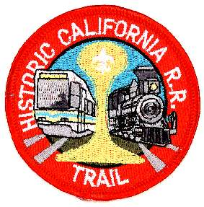
Sacramento Historic Train Trail
Requirements:
- Hike the trail, as shown on the map, from the Railroad Museum in Old Sacramento to the 13th Street Station and take light rail to the Butterfield Station. Return by Light Rail to Old Sacramento. Review city hiking rules in the Scout Handbook.
- Visit the California State Railroad Museum
- File a report with the Golden Empire Council listing the names of Scouts and Scouters who completed the hike.
- Patches can be purchased from the Golden Empire Council Scout Store.
How to take the hike
1) California State Railroad Museum, 125 I St.
Walk down Front Street. From the Railroad Museum to 3rd and R Streets is one mile.
2) Passenger Station, Front Street
This reconstructed Central Pacific station was used by the SVRR in its later years. Just south of here at Front and K Streets, construction of the Central Pacific Railroad began on January 8, 1863. Walk east to 1st Street and south, under the Capitol Mall tunnel to Front Street. Walk to the O Street overpass over I-5 and head east to 3rd Street. Walk south on 3rd to R Street.
3) 3rd and R Streets.
The historical plaque on the building on the southwest corner marks the site of the original SVRR station. Walk east on R to 13th Street, ¾ of a mile.
4) 13th Street Station
Board the Butterfield-bound Light Rail. Faire is $1 for 90-minutes of travel. It’s 9 miles to the Butterfield Station.
5) 17th Street
On August 17, 1855, 200 people were taken on the first SVRR excursion, as far as 17th Street. John Sutter chose to walk home from 17th Street, having enough of the new mode of transit.
6) Brighton
The town of Brighton was started in 1849 on the south bank of the American River. It was later moved to the intersection of the SVRR and Central Pacific lines (which cross here.) The Brighton Station was the first outside of Sacramento. All that’s left of Brighton today is Brighton Avenue, an industrial street that parallels the track on the south.
7) Butterfield Station
The end of the light rail line. This is near where Patterson’s Station was on the SVRR. A.P. Patterson built American Fork House or Ten Mile House in 1849. The SVRR make its first money by transporting soldiers here on November 10, 1855; the sum was $50. Later, Patterson left and the station was renamed Mayhew for its agent. Mayhew Road is just west of the Butterfield Station.
8) Take the return train back to downtown.

