Monterey Kayaking and Mt. Madonna Camping
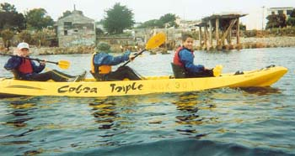

We had a great kayaking trip on the Monterey Bay on Feb. 15th. There was a slight change in plans since we were going to kayak at Elkhorn Slough, but very high and low tides on the same day made the conditions too difficult. Monterey Bay was very calm and after a short class on kayaking, we buddied up and set out on the bay.
We went up to the Monterey Bay Aquarium and saw jellyfish, kelp, California Sea Lions, Harbor Seals, Homo Scubadivas and other sea life. On our way back, we kayaked into the marina to see Sea Otters, starfish, sea cucumbers and a HUMPBACK WHALE! The whale was around 30 yards from us and we saw the ridge back of the whale.
After our kayaking and lunch, we headed up over Hecker Pass to Mt. Madonna County Park. We had a great campsite among California Redwoods and were secluded from the winds. The outing was led by Thomas Clegg and Michael Ahn/ After setting up camp, we set up a tarp canopy over the picnic tables. This really proved helpful as it was a dry place for us to cook breakfast and to store extra gear during a brief rainstorm. The brief rain showed why it’s better to camp in the open rather than under the trees. The rain started after midnight and lasted until 2:30 AM, but the redwoods kept dropping large droplets of rain until 6 AM.

