Coyote Creek Trail
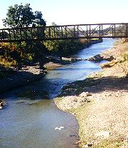
Coyote Creek Bike path, bridge over Coyote Creek near Parkway Lake, San Jose
The Coyote Creek Trail is a long, paved, mostly level multi-use trail that runs along Coyote Creek from South San Jose, through the Coyote Valley, and ends at Anderson Lake in Morgan Hill. It's a popular trail for walkers, bikers, equestrians, and skaters. A large part of it is through rural areas, but it is a well-developed trail. There are parks, picnic tables, and benches along the way, as well as emergency phones. Its north end technically begins at the middle of the north part of San Jose's Hellyer Park, near the velodrome. You can exit the park just past the velodrome and take surface streets for a couple of blocks north to an unmarked paved trail. This segment of trails runs along the creek between Yerba Buena Road and Capital Expressway. However, I get a little nervous riding along the grafitti-covered pathway here next to a weed-choked field, so I wouldn't recommend going through this part alone. The official Coyote Creek Trail, however, is no problem. As it heads south, it passes through increasingly upscale neighborhoods and gets more scenic. In Hellyer Park, the trail crosses the creek, goes under the Hellyer Avenue bridge, follows along a deep and shady part of Coyote Creek, and arcs around Cottonwood Lake. Hellyer Park is a popular picnic area, with playgrounds and playing fields. Cottonwood Lake is planted with trout in the cooler months. A separate path circles around the lake.
Leaving Hellyer Park, the trail goes under Hwy 101, and runs through a deeply-shaded segment along the backyards of some of the southernnmost high-tech companies in the Silicon Valley. At Silver Creek Valley Road, you can depart from the trail and take the road up the hill, passing through the exclusive Silver Creek development and enter the Evergreen Valley. Continuing south, the Coyote Creek Trail passes by some fruit orchards (with no fences or signs saying you can't pick the fruit) and eucalyptus-lined percolation ponds.
At Silicon Valley Blvd., the trail passes behind the Holiday Inn, which has a restaurant if you're hungry and not too dusty. For fast food, go west on Bernal Road to the shopping center at Santa Teresa Blvd. If you continue west on Bernal Road, you'll enter Santa Teresa Park. A bridge over Coyote Creek at Silicon Valley Blvd. leads east and south to the new Basking Ridge housing development. A multi-use path parallels the road there for awhile. Instead of turning south towards Basking Ridge, you could go straight onto Piercy Road, which follows along the hills through one of the last remaining rural areas in Silicon Valley, passing by horse ranches, greenhouses, and orchards. Piercy Road ends up back at Silver Creek Valley Road near Coyote Creek.
South of Bernal Road, the Coyote Creek Trail ducks under Hwy 101, passes by some new subdivisions. It skirts Metcalf Park, which has lawns, a playground, basketball courts, picnic tables, restrooms, and drinking fountains, making it a good place for a rest stop. The trail continues alongside a series of percolation ponds, including one used for water-skiing, then crosses Coyote Creek near Parkway Lakes. Parkway Lakes is an excellent fishing spot, where no state fishing license is required. It's heavily planted with trout in the winter, catfish in the summer, and a few large sturgeon for an extra thrill. (You may notice that I like to go fishing. Sometimes I carry a pack rod when I go biking.)
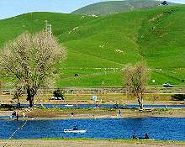 | 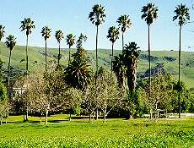
Parkway Lakes, San Jose | Coyote Ranch, Coyote Valley
South of Metcalf Road, the trail enters the rural Coyote Valley. You can cross Monterey Highway and take it south to the tiny community of Coyote. The Coyote Bait and Tackle Shop is there and is one of the best places in the South Bay for fishing gear and information on local fishing conditions. They also have drinks and snacks. The safest way to get back to the Coyote Creek Trail is to head south to Bailey Avenue, cross Monterey Highway, and take it back north to Coyote Ranch Road. The trail passes by Coyote Ranch, which is an old ranch now used for corporate and group picnics and barbecues, with an old-fashioned country atmosphere.
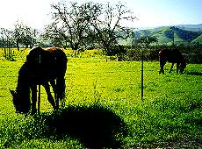
Horses by Coyote Creek Trail
From there the trail passes by a kennel club, horse ranches (with friendly, curious horses), sunny open fields, fruit tree-laden orchards, and the Riverside Golf Course. There's a rest stop near the Golf Course. You can enter the golf course itself and stop at the country club for a meal or drinks.
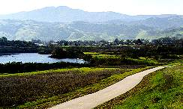
Coyote Creek Trail near a percolation pond in the Coyote Valley
South of the golf course, the trail runs through more open fields past large reed-lined percolation ponds. You can go fishing in these ponds, but catching is another matter. Past Ogier Avenue, it passes by an R/C airplane field run by a model airplane club. There are bleachers and porta-potties here. This is a good place to stop for a rest and a free airshow, as you watch the fast, agile planes do their showy aerobatics.
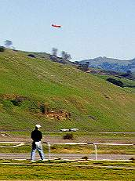
R/C model airplane club field north of Anderson Dam
The trail follows along a wide portion of the creek. It passes under Hwy 101 and enters a complex of dirt and paved trails near Anderson Dam. The paved trail dead-ends on the north side of the creek. At a cross-roads, you can cross the creek and take the gravel path that turns into Malaguera Avenue. This road eventually hits Cochrane Road, which leads into Coyote Creek Park. The tree-shaded park here has picnic areas and playing fields along some of the most scenic stretches of the Coyote Creek. The creek here below Anderson Dam is planted with trout in season. Anderson Reservoir is the largest reservoir in Santa Clara County and can be an excellent warm-water fishery. In the wintertime, during particularly heavy rainy seasons, Anderson Dam can spill, like it did for the past 2 wet years, producing the most spectacular waterfall in the Bay Area. Unfortunately, it also tends to flood the creek, closing and sometimes damaging the trail.
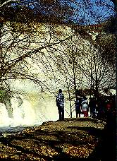
Falls at Anderson Dam spillway, Feb. '98
From Anderson Dam, you can head back along the Coyote Creek Trail. Keep in mind that the afternoon winds tend to blow south, so you can face a constant stiff headwind heading back. You might consider starting the trip at Anderson Dam and heading north, so you head downwind on the return trip. Either that, or arrange for a car shuttle. Alternatively, you can take Cochrane Road west and head back north on Monterey Road, along a stretch that used to be called "Blood Alley" before the Hwy 101 bypass was built, but it's about as pleasant as riding on a freeway. Santa Teresa Blvd is an alternate route, which can reached by taking Tilton Avenue west off Monterey Road. It's a straight, fast, 2-lane country road that runs by several farms and nurseries. Just past Bailey Avenue, it widens out and rises over a low hill. All of a sudden, you drop into the edge of the sea of suburbia at the southern tip of the Silicon Valley, and you're back to civilization. You could take Santa Teresa Blvd. to the Santa Teresa Light Rail Station and take the trolley to the Alamitos Creek Trail (see next).

